**2023**

**Year 12 Integrated Science – Unit 3**

**Task 6: Biodiversity in a Local Ecosystem**

**Weighting: 10%**

**Assessment Type: Investigation**

**Name: ________________________**

**Date submitted: ________________**

|  |  |
| --- | --- |
| **Total Mark** |  |

*I acknowledge that all the information contained in this task is my own work and not taken from other sources. If other sources have been used they have been acknowledged in my references.*

____________________________________

(Student Signature)

*Please see SEQTA for teacher feedback and comments.*

**Background:**

**What is biodiversity?**

Biodiversity can be defined on a variety of levels. Ecosystem biodiversity refers to the variety of habitats within a particular area or region. This inquiry focuses on species biodiversity, or the variety of plants and animals in a particular habitat. On a more complex level, genetic biodiversity looks at the variety of characteristics within a particular species.

The opposite of species diversity is monoculture. The term monoculture refers to a situation in which only one species occupies a particular area or region. Examples of man-made monocultures include lawns and farms (such as wheat fields or pumpkin patches).

**Why is biodiversity important?**

Habitats that have a greater variety of different species of plants and animals have a greater biodiversity. These habitats are also healthier and more stable. One reason diverse communities have greater levels of health is that organisms of the same species tend to be more spread out. This reduces the ability of a disease to spread throughout a habitat. Additionally, if a certain type of species of tree or plant does become infected, the other species will remain and continue to provide the habitat components for the organisms in that area.

In an area consisting of monoculture, an area with only one type of plant species growing, the plants are more susceptible to disease and other stresses because they are all the same and less spread out (no other types of plants between them). As a result, [the entire habitat can be dramatically altered when impacted by disease or other stresses]. Human-made monocultures (crops, etc.) are created to make harvesting easier. However, they typically require larger amounts of pesticides and herbicides (to prevent diseases and/or “weeds”) and larger amounts of energy and labour to maintain before harvesting.

**PRE-OBSERVATION DATA:**

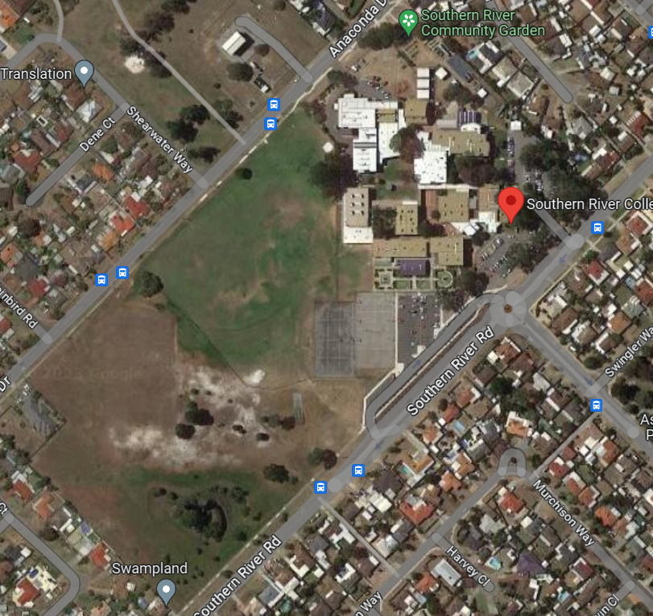

1. On the school map provided above, identify the two locations (as chosen by the class) that have the greatest potential for biodiversity. (2 marks)

Of the two chosen locations, you will compare the biodiversity of each site. To do this, you will need to mark out the plots using string, pegs and collect observations.

1. Write a hypothesis for this investigation. (2 marks)

__________________________________________________________________________________________________________________________________________________________________________________________________________________________________________

1. Describe how you and the class are going to keep your observations fair. What do you need to do at each location to do this? (2 marks)

________________________________________________________________________________________________________________________________________________________________________________________________________________________________________________________________________________________________________________________

1. Identify three (3) risks that are associated with wildlife observations. (3 marks)

__________________________________________________________________________________________________________________________________________________________________________________________________________________________________________________________________________________________________________________________________________________________________________________________________________________________________________________________________________________________________________________________________________________________________

1. Describe some precautions you and your peers can take to reduce or stop each of these risks. (3 marks)

__________________________________________________________________________________________________________________________________________________________________________________________________________________________________________________________________________________________________________________________________________________________________________________________________________________________________________________________________________________________________________________________________________________________________

**PART ONE: VEGETATION SURVEY**

Follow the below steps while completing the attached *Vegetation Survey* sheet.

1. Locate the area for the plot in the first location.
2. Accurately measure and outline the plot.
3. Search the area of grass. Be sure to tally the different species of grass and take pictures if you are unsure of the variety. If you find more than one variety of grass estimate the percentage of the plot covered by each type.
4. Now, look for flowers. Are there any invasive species of flower? Mark each type in the *Tally of different species* column and tally the total number of invasive flowers in the *tally of all plants found* section.
5. Repeat step 4 for native and non-native flowers.
6. Repeat step 4 for thick ground covers, brush, bushes, shrubs, trees and fungus, mosses or lichens.

*Remember to tally different species as well as the total number of all plants found for each section.*

1. Now complete the steps above for the second location.

*Diversity calculations will be completed in class.*

**PART TWO: WILDLIFE SURVEY**

Follow the below steps while completing the attached *Wildlife Biodiversity Index Data Collection Document.*

1. Locate the area for your plant in the first location.
2. Accurately measure and outline the plot.
3. Choose a location within the plot (or just outside the plot) to complete the observation.
4. Find a comfortable position and remain quiet for a minimum of 2 minutes to allow wildlife to return to the area (they may have been scared off by your movements into the area).
5. Tally the total number of different species, the total number of each species and the total number of all species found/observed for each group of animals.

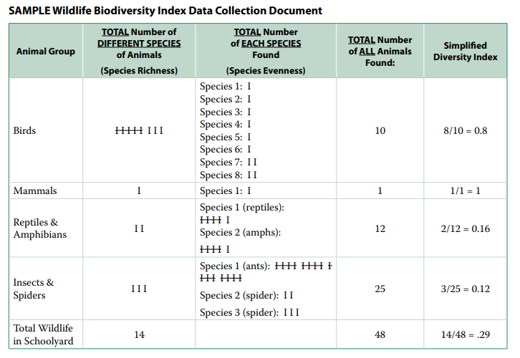*See SAMPLE Wildlife Biodiversity Index Data Collection Document* *below.*

1. Complete the steps above for the second location.

*Diversity calculations will be completed in class.*

**BIODIVERSITY INVESTIGATION – VEGETATION SURVEY**

**Site Location:** __________________________ **Quadrant Size:** _________________

**Current Weather** *(circle all that apply)*

|  |  |  |
| --- | --- | --- |
| Temperature _________°C | Rain / Clear  Scattered clouds  Complete cloud cover | Wind:  Calm  Breezy  Gusty |

|  |  |  |  |  |
| --- | --- | --- | --- | --- |
| **Item/Type and Description** | | **Tally of *Different species* of Plants** | **Tally of *ALL* plants found (or percentage of area covered or estimated #)** | **Simplified Diversity Index** |
| *If none present, put an X through and skip to the next item/type | | | | |
| **Grass** | Mowed lawn/grass |  |  |  |
| Meadow or tall grass (not mowed) |  |  |  |
| **Flowers**  (Growing individually, annuals or perennials, **not** bushes or trees) | |  |  |  |
| **Ground cover**  (outer edge *less than* 30cm apart and *less than* 30cm tall) | |  |  |  |
| **Bushes or Shrubs**  (*more than*30cms tall, but typically *less than* 4.5m tall) | |  |  |  |
| **Trees**  (mature trees more than 4.5m tall) | |  |  |  |
| **Fungus, Mosses or Lichens**  (can be found growing on trees, logs or the ground) | |  |  |  |
| **TOTALS (Numbers)** | |  |  |  |

**BIODIVERSITY INVESTIGATION – WILDLIFE BIODIVERSITY**

**Site Location:** __________________________ **Quadrant Size:** _________________

**Current Weather** *(circle all that apply)*

|  |  |  |
| --- | --- | --- |
| Temperature _________°C | Rain / Clear  Scattered clouds  Complete cloud cover | Wind:  Calm / Breezy / Gusty |
| Survey timing Beginning Time:  ____________ am / pm | Ending Time:  ________________ am / pm | Stationary Observation(s):  _____________ min |

|  |  |  |  |  |
| --- | --- | --- | --- | --- |
| **Animal Group** | ***Total* number of *different species* of Animals** | ***Total* number of *each species* found** | ***Total* number of *all* animals found** | **Simplified diversity index** |
| **Birds** |  |  |  |  |
| **Mammals** |  |  |  |  |
| **Reptiles** |  |  |  |  |
| **Amphibians** |  |  |  |  |
| **Insects & Spiders** |  |  |  |  |
| **Total wildlife in location** |  |  |  |  |

**BIODIVERSITY INVESTIGATION – VEGETATION SURVEY**

**Site Location:** __________________________ **Quadrant Size:** _________________

**Current Weather** *(circle all that apply)*

|  |  |  |
| --- | --- | --- |
| Temperature _________°C | Rain / Clear  Scattered clouds  Complete cloud cover | Wind:  Calm / Breezy / Gusty |

|  |  |  |  |  |
| --- | --- | --- | --- | --- |
| **Item/Type and Description** | | **Tally of *Different species* of Plants** | **Tally of *ALL* plants found (or percentage of area covered or estimated #)** | **Simplified Diversity Index** |
| *If none present, put an X through and skip to the next item/type | | | | |
| **Grass** | Mowed lawn/grass |  |  |  |
| Meadow or tall grass (not mowed) |  |  |  |
| **Flowers**  (Growing individually, annuals or perennials, **not** bushes or trees) | |  |  |  |
| **Ground cover**  (outer edge *less than* 30cm apart and *less than* 30cm tall) | |  |  |  |
| **Bushes or Shrubs**  (*more than*30cms tall, but typically *less than* 4.5m tall) | |  |  |  |
| **Trees**  (mature trees more than 4.5m tall) | |  |  |  |
| **Fungus, Mosses or Lichens**  (can be found growing on trees, logs or the ground) | |  |  |  |
| **TOTALS (Numbers)** | |  |  |  |

**BIODIVERSITY INVESTIGATION – WILDLIFE BIODIVERSITY**

**Site Location:** __________________________ **Quadrant Size:** _________________

**Current Weather** *(circle all that apply)*

|  |  |  |
| --- | --- | --- |
| Temperature _________°C | Rain / Clear  Scattered clouds  Complete cloud cover | Wind:  Calm  Breezy  Gusty |
| Survey timing Beginning Time:  ____________ am / pm | Ending Time:  ________________ am / pm | Stationary Observation(s):  _____________ min |

|  |  |  |  |  |
| --- | --- | --- | --- | --- |
| **Animal Group** | ***Total* number of *different species* of Animals** | ***Total* number of *each species* found** | ***Total* number of *all* animals found** | **Simplified diversity index** |
| **Birds** |  |  |  |  |
| **Mammals** |  |  |  |  |
| **Reptiles** |  |  |  |  |
| **Amphibians** |  |  |  |  |
| **Insects & Spiders** |  |  |  |  |
| **Total wildlife in location** |  |  |  |  |

**PART THREE: CALCULATING DIVERSITY**

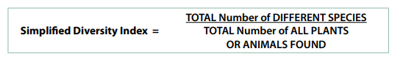Calculate the Simplified Diversity index for both the wildlife and vegetation data. Filling in your values on the respective documents. The formula needed to calculate simplified diversity index is below.

Vegetation Diversity Index calculated correctly for all plants (5 marks)

Wildlife Biodiversity Index calculated correctly for all animals (5 marks)

**PART FOUR: POST OBSERVATION QUESTIONS**

1. Define biodiversity in your own words. (1 mark)

__________________________________________________________________________________________________________________________________________________________________________________________________________________________________________

1. If we collected vegetation or animal data at different times of the year, would we get the same Diversity Index calculations? Why or why not? (2 marks)

__________________________________________________________________________________________________________________________________________________________________________________________________________________________________________

1. An area with lots of weeds might score a high Diversity index. Does a high Diversity index always mean a habitat is healthy? Explain your answer. (3 marks)

________________________________________________________________________________________________________________________________________________________________________________________________________________________________________________________________________________________________________________________

1. What are some limitations or problems with random sampling to calculate diversity?

(3 marks)

________________________________________________________________________________________________________________________________________________________________________________________________________________________________________________________________________________________________________________________

1. Compare your data to a peer’s. Do you have similar values in the Vegetation Survey? Suggest reasons why or why not? (2 marks)

__________________________________________________________________________________________________________________________________________________________________________________________________________________________________________

1. Compare your data to a peer’s. do you have similar values in the Wildlife Survey and Simplified Diversity Index? Suggest reasons why or why not. (2 marks)

__________________________________________________________________________________________________________________________________________________________________________________________________________________________________________

1. State your Simplified Diversity Index total from your Vegetation Survey for both your first and second locations. (2 marks)

|  |  |
| --- | --- |
| Location One: ___________________ | Location Two: _______________________ |

1. Compare your vegetation Survey Data from both locations. Is there a difference in overall DSI? Are there any similarities or differences within specific items? Give reasons for these similarities and differences. (6 marks)

________________________________________________________________________________________________________________________________________________________________________________________________________________________________________________________________________________________________________________________________________________________________________________________________________________________________________________________________________________________________________________________________________________________________________________________________________________________________________________

1. State your DSI total for your Wildlife Biodiversity Index Data for both your first and second locations. (2 marks)

|  |  |
| --- | --- |
| Location One: ___________________ | Location Two: _______________________ |

1. Compare your Wildlife Biodiversity Index Data from both locations. Is there a differences in overall DSI? Are there any similarities or differences within specific animal groups? Give reasons for these similarities and differences. (6 marks)

________________________________________________________________________________________________________________________________________________________________________________________________________________________________________________________________________________________________________________________________________________________________________________________________________________________________________________________________________________________________________________________________________________________________________________________________________________________________________________

**END OF ASSESSMENT**